Circuit Analysis (Lab # 2)

Experiment 2: Measurements of Waveforms and Fundamental Quantities, Basic resistive circuits.

Name: RABEEA IMTIAZ

Date: ..................................
Registration No: 2025-CE-75

Grade and Signature: ...........................

CL03 | Make measurements in their own constructed electric circuits.
Psychomotor/ Affective | Levell  (1) | Level2  (2-3) | Level3  (4-5) | Level4  (6-7)
Report Marks (3) |  |  | Total  marks  (10)

Objectives: This experiment will provide exposure to measurements of waveforms and Fundamental Quantities, Basic resistive circuits. A primary purpose of this lab course is for you to master the use of electronic test equipment and measurement of fundamental quantities.

Equipment required:
Power Supply, Breadboard, Oscilloscope, Signal Generator Connecting wires, Resistances, Multimeter.
Procedure

Experiment# 1
SIGNAL GENERATOR AND OSCILLOSCOPE
- Use the signal generator and the oscilloscope to perform the following tasks.
- Build circuit 'A' shown below in Figure 1.
- Set the signal generator to generate a sinusoidal signal with a frequency of 100 Hz and peak-to peak voltage of 5V.
- Set up one probe across input signal, and another across Rl and R2 alternatively.
- Measure and draw all the voltages and time related parameters on the graphs below.
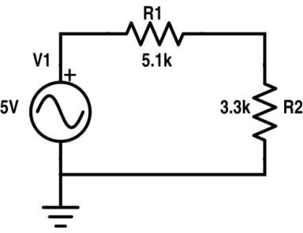
Figure 1 Circuit 'A'

Resistor | Input voltage | RMS Voltage | P-P Voltage
RI | 5V | 1.07V | 3.03V
R2 | 5V | 0.70V | 1.97V




−2.5 V (negative peak) at 7.5ms -1.52V at 7.5ms



Figure2Input Voltage Signal Figure3Voltage Signal across R1

0.98V at 2.5ms +3.5V at 2.5 ms
-0.98V at 7.5ms -3.5V at 7.5ms

Figure5 Voltage Signal across R2 Figure6 Draw 7V Sinusoidal
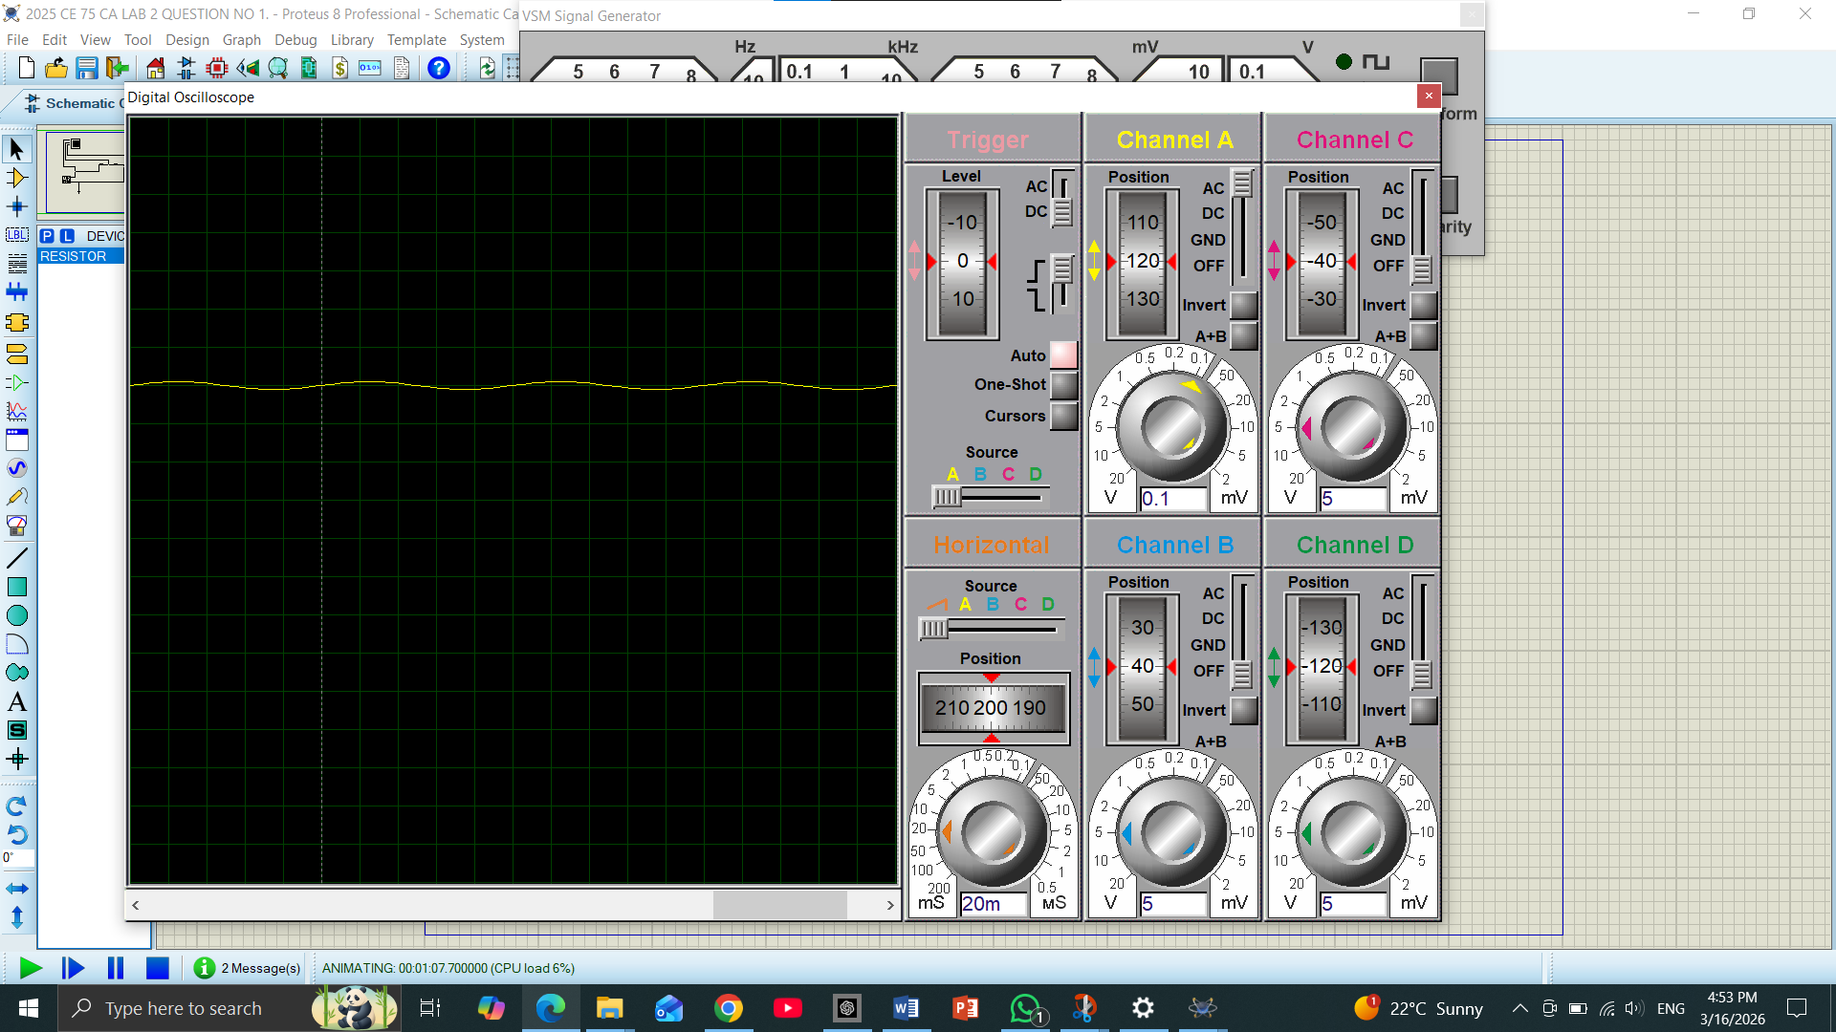

"The input signal is a sinusoidal wave with a peak-to-peak voltage V_{PP} of 5V and a frequency of 100Hz. It serves as the reference signal for the entire circuit, with a measured time period of 20ms."
Figure 2 Input Voltage Signal

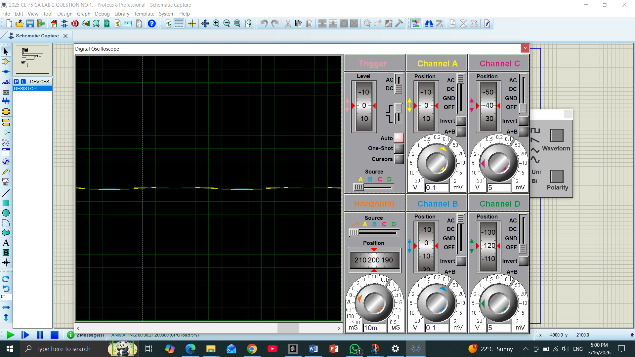

Figure 3 Voltage Signal across R1 "This graph shows the voltage drop across the first resistor R1 = 5.1kOHM). The measured peak-to-peak voltage is 3.03V. The signal remains in phase with the input but has a reduced amplitude due to the resistor's impedance."

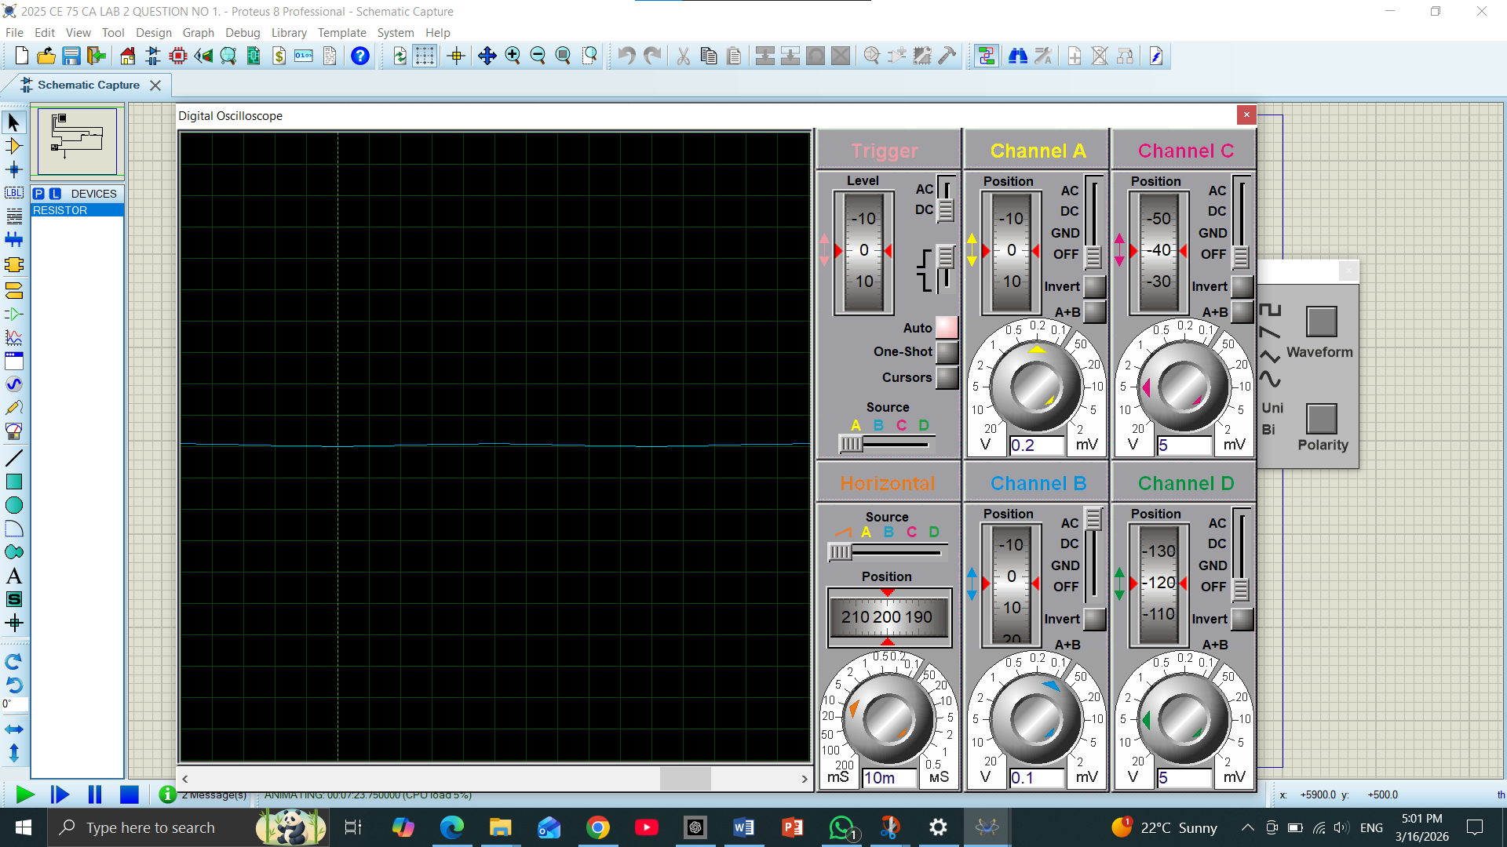

Figure 5 Voltage Signal across R2 The voltage across R2(3.3k OHM was measured relative to the ground. The peak-to-peak value is 1.97V. Since R2 has a lower resistance than R1, it exhibits a smaller voltage drop according to the voltage divider rule.

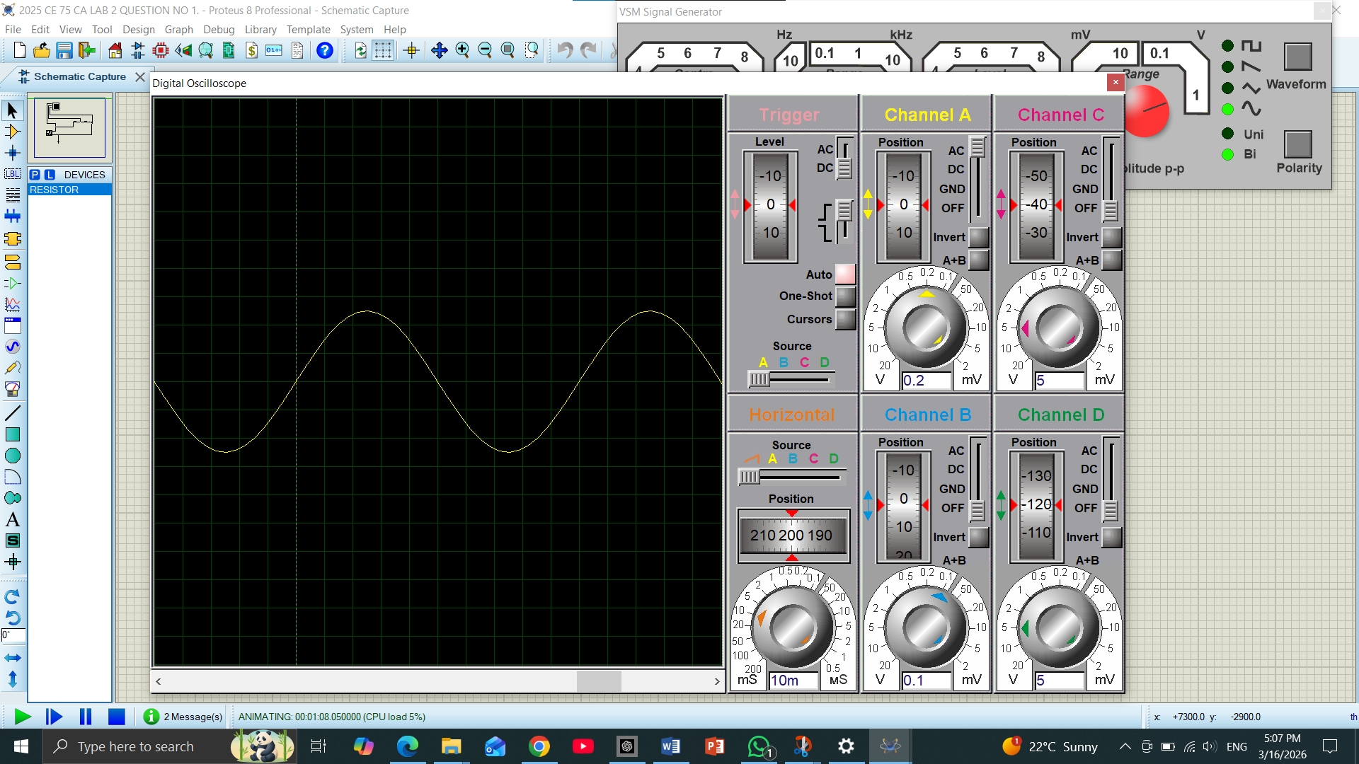

Figure 6 Draw 7V Sinusoidal
"For this task, the signal generator was adjusted to an amplitude of 3.5V, resulting in a 7V peak-to-peak output. This wave is vertically larger than the previous signals, covering 7 divisions on the oscilloscope grid at a 1V/Div scale."

UNDERSTANDING EXPLANATION:
A sinusoidal signal from the signal generator was applied to a resistor network (R1, R2, R3). The oscilloscope measured the input signal and voltages across each resistor. Channel A showed the input, Channel B measured R1, Channel C measured R2, and Channel D measured R3.
Probes were connected with the tip on one end of the resistor and ground on the other. Screenshots were taken for all waveforms. RMS voltage, peak-to-peak voltage, and frequency were measured, and the time period was calculated as T = 1/f.
The experiment showed a 200 Hz sinusoidal waveform with 7 V peak-to-peak, and the voltages across resistors confirmed the expected voltage division.

Experiment # 2
SIGNAL GENERATOR AND OSCILLOSCOPE
- Use the signal generator and the oscilloscope to perform the following tasks.
- Build circuit 'B' shown below in Figure 7.
- Set the signal generator to generate a sinusoidal signal with a frequency of 200 Hz and peak-to peak voltage of 7V.
- Set up one probe across input signal, and another across Rl, R2 and R3 alternatively.
- Measure and draw all the voltages and time related parameters on the graphs below.
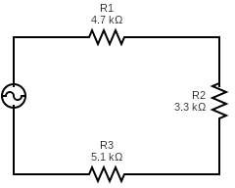
Figure 7 Circuit 'B'

Resistor | Input voltage | RMS Voltage | P-P Voltage
Rl | 7V | 0.89V | 2.51V
R2 | 7V | 0.62V | 1.76V
R3 | 7V | 0.96V | 2.73V
Rl and R2 | 7V | 1.51V | 4.27V
R2 and R3 | 7V | 1.59V | 4.49V




Figure8InputVoltage Signal Figure9VoltageSignalacrossR




Figure10VoltageSignalacrossR2 Figure11VoltageSignalacrossR3




Figure12VoltageSignalacrossR1andR2 Figure13VoltageSignalacrossR2andR3

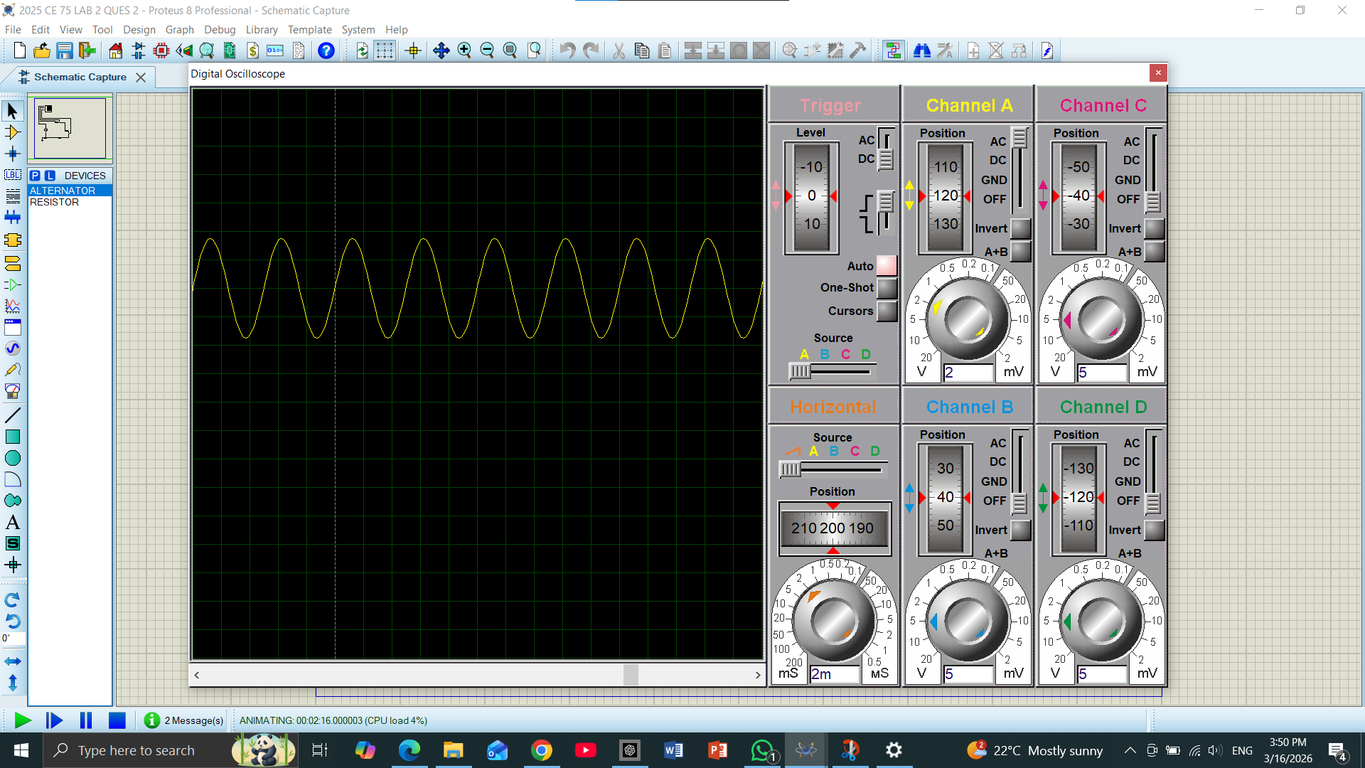

Figure 8 Input Voltage Signal The input signal was measured using Channel A. It is a sinusoidal wave with a peak-to-peak voltage v_{pp}) of 7V and a frequency of 200Hz. The time period for one cycle is 2ms

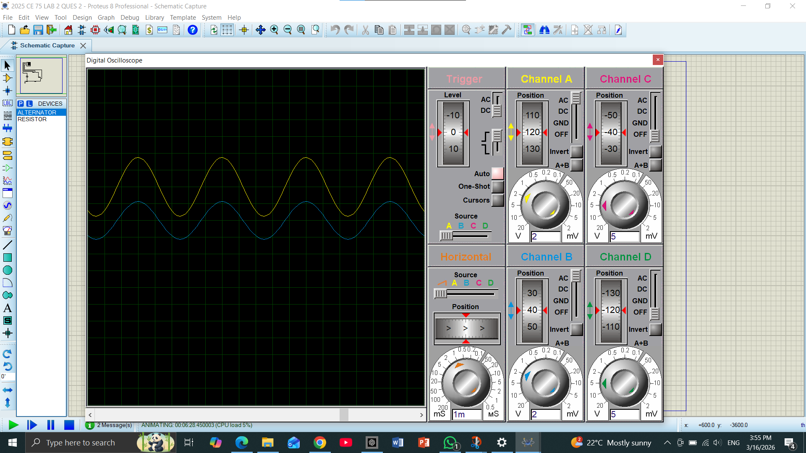

Figure 9 Voltage Signal across Rl By placing the probe across R1 (4.7K OHM), a voltage drop was observed. The measured peak-to-peak voltage is 2.51V. This value is proportional to the resistance of R1.

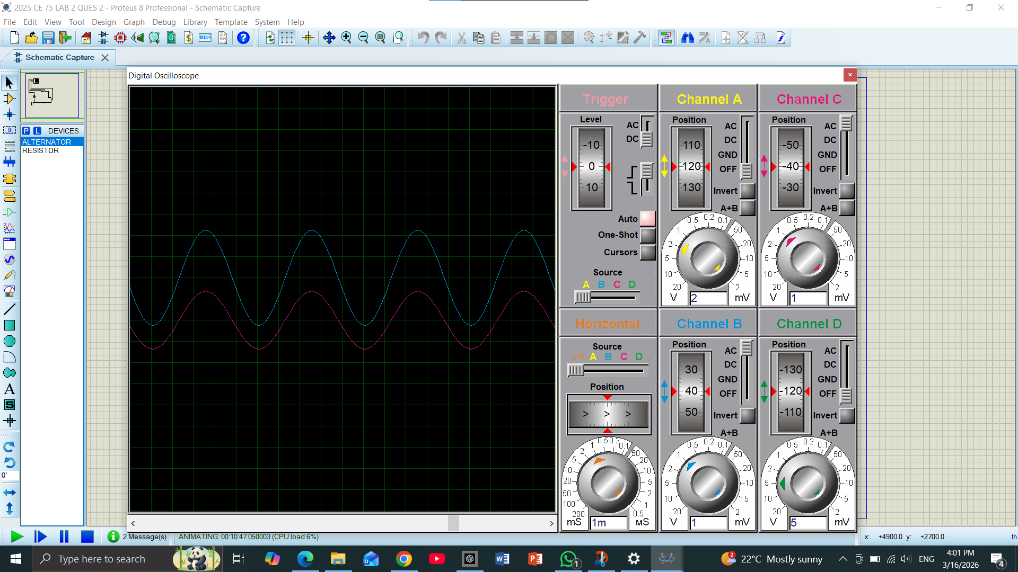
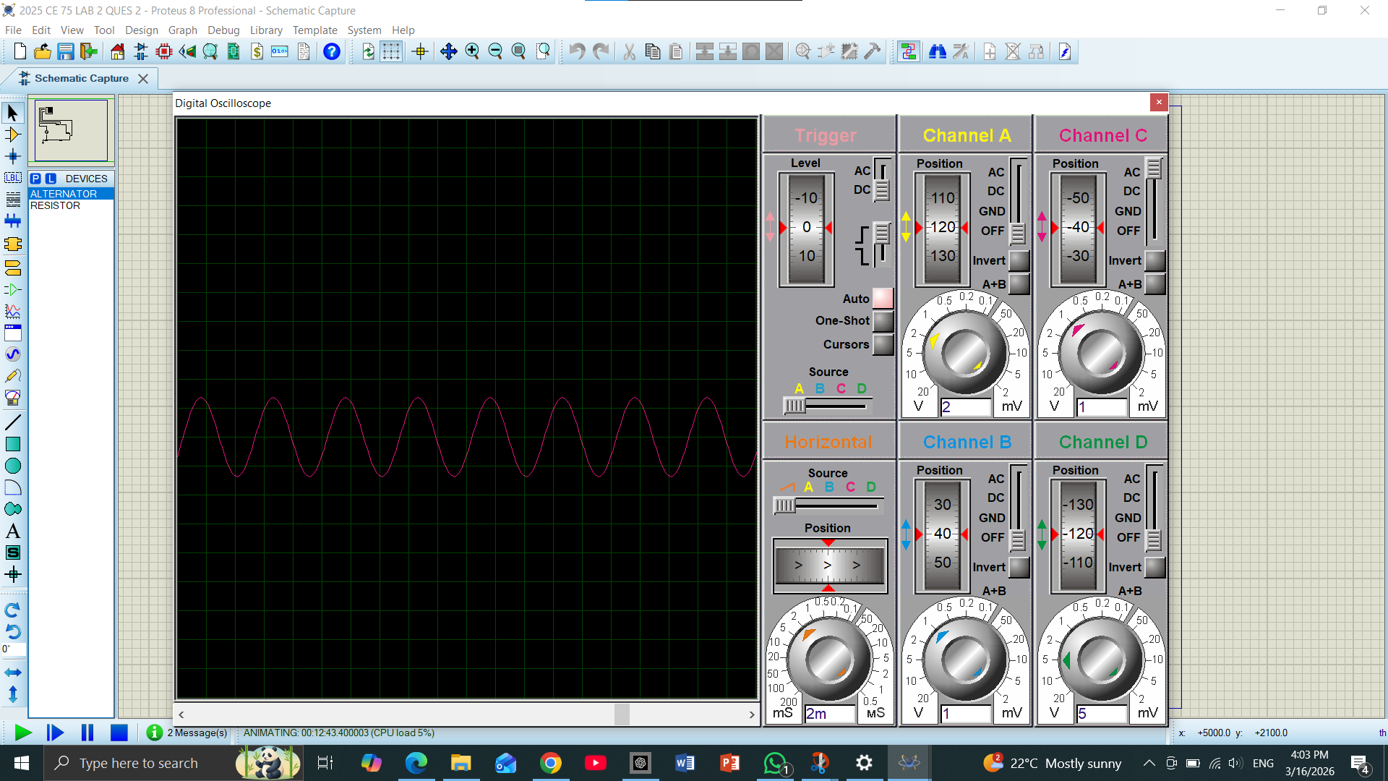
Figure 10 Voltage S• 1gna /across R2 The voltage drop across R2 (3.3k OHM) was measured by the potential difference between its two terminals. It shows a V_{PP} of 1.76V, which is the lowest d

Figure 11 Voltage S• igna /across R3 R3 (5.1k OHM) is the last resistor connected to the ground. The measured voltage across it is 2.73V. It has the highest voltage drop among the three because it has the highest resistance.

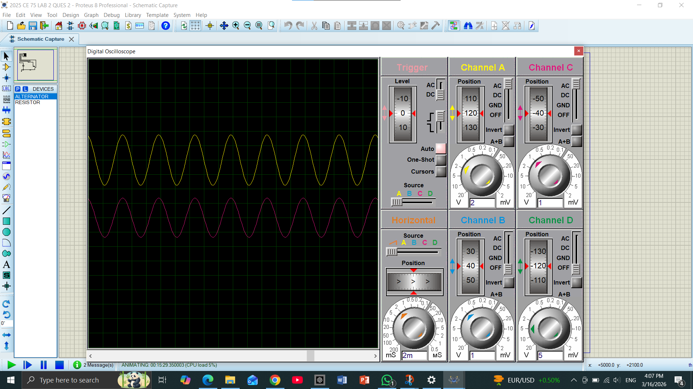

Figure 12 Voltage signaI across Rl andR2 F
This was measured from the start of R1 to the end of R2. The combined voltage drop is 4.27V, which is the sum of individual drops across R1 and R2.
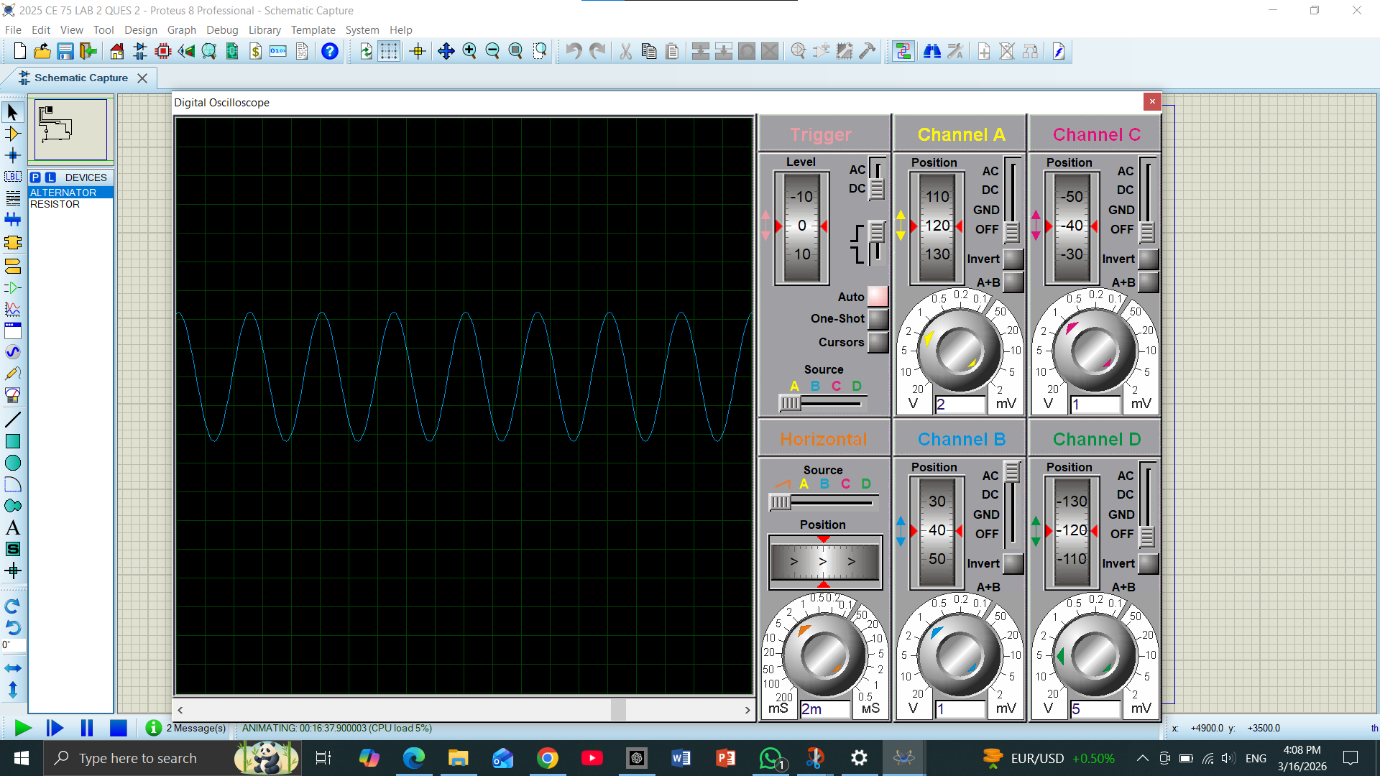

• 1gure 13 Voltage Signal across Rland R3
• This was measured from the junction of R1/R2 to the ground. The combined voltage is 4.49V. It represents the total potential difference remaining after the first resistor.

UNDERSTANDING EXPLANATION:
In this experiment, Circuit ‘B’ was built in Proteus. The signal generator was set to produce a 200 Hz sinusoidal waveform with 7 V peak-to-peak voltage. One oscilloscope probe was connected to the input signal, and the other probe was connected across R1, R2, and R3 alternately to measure their voltages.
RMS voltage, peak-to-peak voltage, and time-related parameters were recorded for each resistor. This experiment demonstrated how the input signal is divided across the resistors and how to measure voltage and time parameters using Proteus and the oscilloscope.

